School Registration System

Prepared by: OJONGAGBOR AGBORETA NDIP
Instructor's Name: MR. TAH JOEL
Course Title: INTRODUCTION TO DATABASE
Date of Submission: FRIDAY 11 APRIL 2025

INTRODUCTION
This project is a simple School Registration System designed to allow students to register online. It captures student details using a web form and stores them in an MS Access database via ASP Classic and IIS server hosting.
Brief Description of the Report
The report explains how a beginner-level student can develop a simple school registration system using front-end and back-end tools. It covers the entire development process from planning, design, database setup, server configuration, and testing.
Objective of the Report
- To create a user-friendly school registration system
- To understand database connection and data processing.
- To learn how to configure and use a local server (IIS).
Importance of Registration
Form in Web Application
A registration form is a vital feature of many web applications. It enables user interaction, collects important data, and ensures proper record-keeping and access management for both users and administrators.
Project Scope
The project covers:
- Designing an HTML registration form
- Styling the form using CSS
- Creating a database in MS Access
- Establishing ODBC connectivity
- Writing server-side processing using ASP Classic
- Hosting the application locally using IIS
Tools and Technologies Used
- Frontend: HTML, CSS
- Backend: ASP Classic (VBScript)
- Database: Microsoft Access (.accdb)
- Web Server: Internet Information Services (IIS)
- Connectivity: ODBC
System Design
Form Layout Design:
The registration form includes the following fields:
- Full Name
- Email Address
- Phone Number
- Date of Birth
- Course Selection
Database Design:
Database Name: school_registration.accdb
Table Name: Students
Fields/Columns:
- ID (AutoNumber, Primary Key)
- Name (Text)
- Email (Text)
- Phone (Text)
- DOB (Date/Time)
- Course (Text)

IMPLEMENTATION
HTML CODES

- What it does:
- Creates text fields for user input (name, email, etc.)
- Uses <form> to send data to register.asp for processing
Uses the POST method to submit data securely
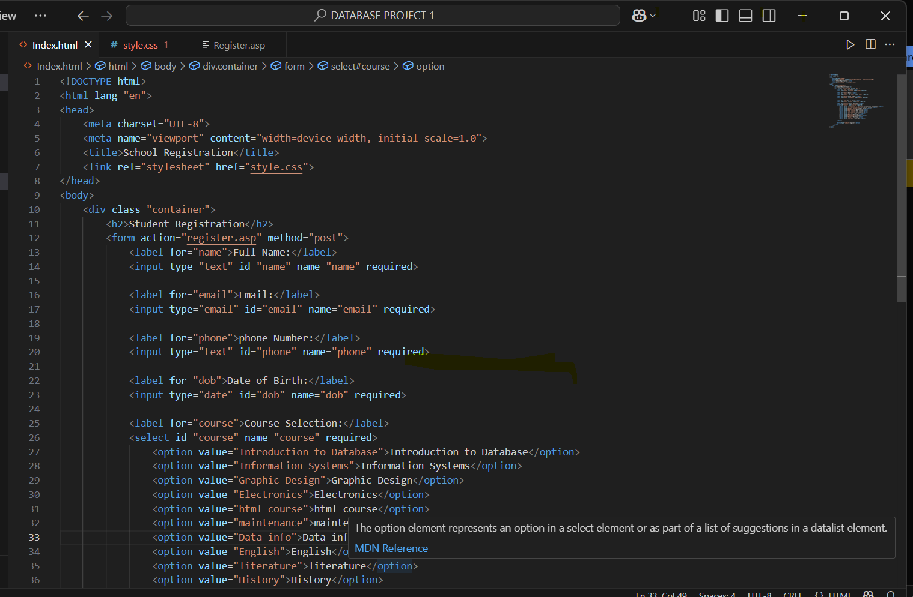

CSS CODES
What it does:
- Centers the form on the page
- Adds spacing and padding for clean layout
- Styles the input fields and button
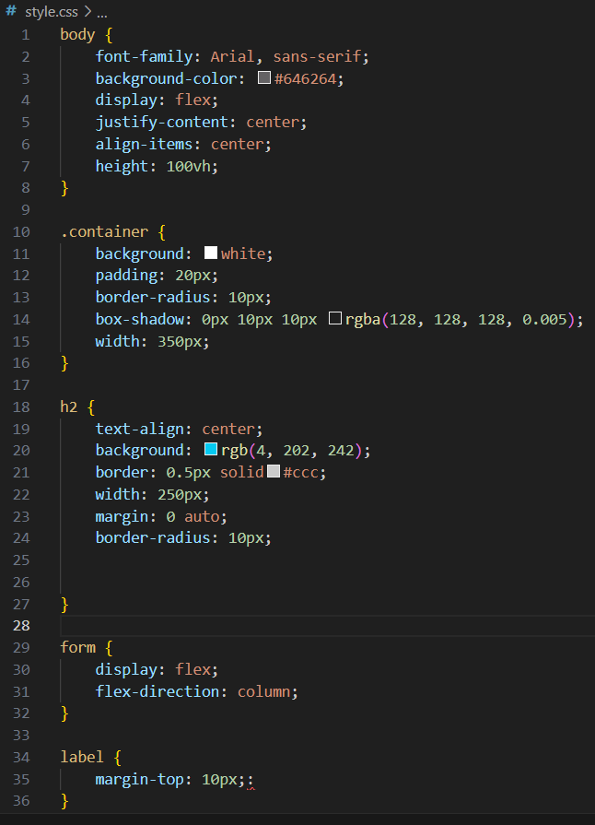

ASP CLASSIC (VB SCRIBTS)
What it does:
- Gets the form data using Request .Form
- Connects to MS Access database via ODBC
- Inserts the student’s data into the Students table
- Shows a success message
- 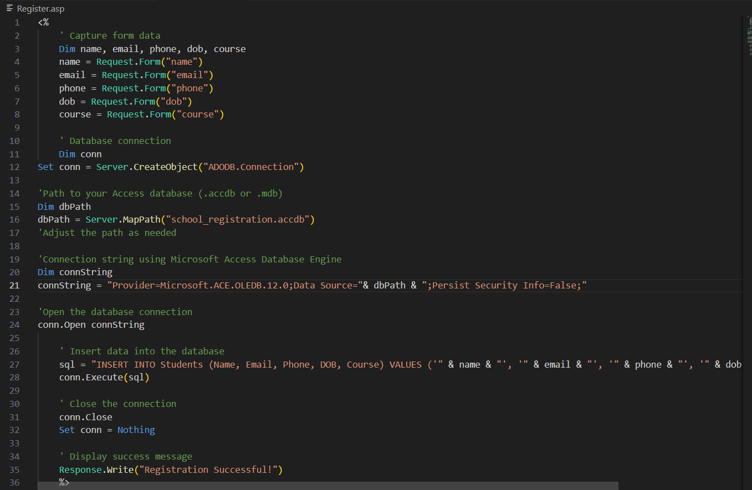

8. Testing
Test cases were executed to ensure the following:
- Data submission works without errors
- Database connection is successful
- Data gets stored correctly in the database
- Success message is displayed after form submission
Explanation of Test Cases:
- Test Case 1: Submit empty form → Expected: validation message
- Test Case 2: Submit valid data → Expected: data stored and success message shown
- Test Case 3: Submit with invalid email → Expected: error message
9. Summary of What Was Achieved
- A fully working student registration form was created.
- IIS was configured to host and run the web application locally.
- Data is properly inserted into an MS Access database as seen below;
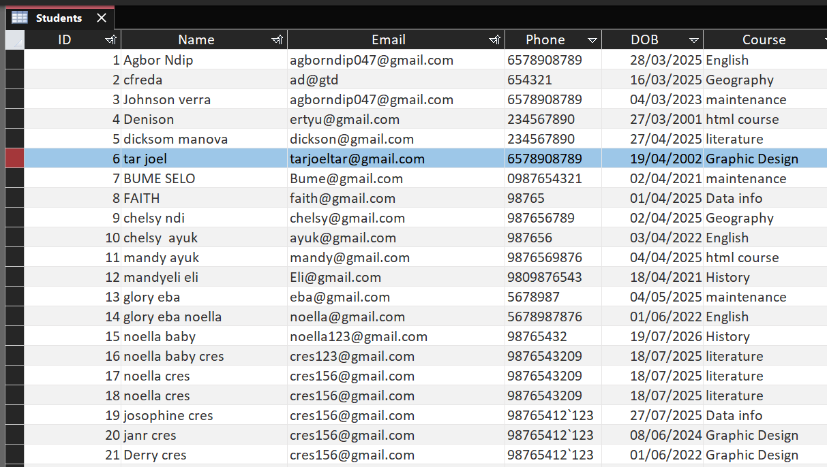
Challenges and Solutions
Challenges | Solutions
ASP not working in IIS | Enabled ASP Classic in IIS settings
ODBC errors | Installed MS Access Database Engine and reconfigured DSN
Access denied to database | Gave permissions to IIS_IUSRS and IUSR users
11. References
- Microsoft Documentation on IIS and ASP Classic
- TutorialsPoint and W3Schools for HTML/CSS basics
- Official Microsoft Access user guides
- Stack Overflow discussions on ODBC setup and VBScript troubleshooting
Conclusion
This project successfully demonstrated the development of a simple web-based school registration system. It involved form design, database creation, server-side scripting, and testing. Future improvements can include email confirmation, an admin dashboard, and PDF certificate generation.

